Cathy Trinh

GGP330 Cartography

09 March 2018

Professor Cox

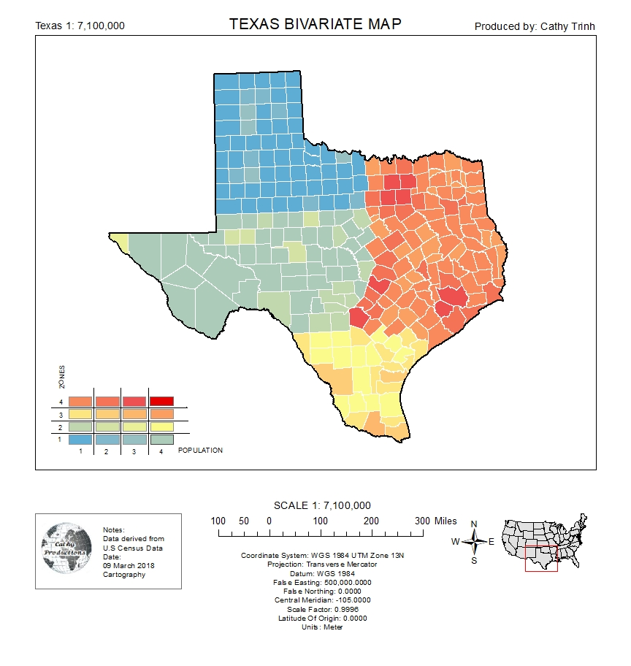

This map basically shows a bivariate map of the state of Texas. Bivariate maps are simply another type of choropleth map that displays a combination of two datasets into one map. The intellectual and visual hierarch of this map is graphically efficient is many ways because it portrays two different factors in one location for the audience. The map shows the population and the zones within the state of Texas without breaking them down into two different maps. Contrast and figure-ground was a little bit tough because I wanted to show the audience the differentiation between the two sets of data. By doing so, I had managed to show the zones in four different broad colors and broken the colors down by four sub-colors. So, the state of Texas is broken down into essentially four zones (North, East, South, West) and I chose blue, orange, yellow, and green. I wanted to pick colors that would not blend so much together but also look pleasing to the eye. Within the zones, you would notice that the population is broken up into 4 categories where the darker colors mean the heavier populated areas and vice versa. This map is used to show a broad outlook of the population in all four zones of the state. The map doesn’t show population specifics because I didn’t create this map for that intention. All of the map elements on this product was basically stuck to the original map creation guidelines where legends are placed on the bottom right and titles are placed on the top center. I adjusted the rest of my map elements off of those. I used the sequential by sequential bivariate legend because it was better for the rank-able categorical data to display. Map projections was a bit difficult because all data that was collected was not always on the same scale. I used what the majority of the data was, which was “GCS_North_American_1983” but I’ve noticed that the boundary was just far too stretched out. Therefore, I had to re-project some data to “WGS 1984 UTM Zone 13N”. This map was basically created to show a broad version of populated areas in each of the four zones that divides the state of Texas.